SET 25: WEBSITE TRAFFIC ANALYSIS

Dataset | Website Traffic
Department | AIML
Course Code / Course Name | DSA0602 / Data Handling and Visualization
Experiment | Data Visualization using R
Name | A Shiva Shankar Reddy
Register Number | 192425174
Date | 20 October 2026
Day | Tuesday

Dataset: Website Traffic

Date | Page Views | Click-through Rate
2023-01-01 | 1500 | 2.3%
2023-01-02 | 1600 | 2.7%
2023-01-03 | 1400 | 2.0%
2023-01-04 | 1650 | 2.4%
2023-01-05 | 1800 | 2.6%

PROGRAM 1: Tableau Line Chart of Page Views
Question: In Tableau, create a line chart to visualize the trend in page views over time. Label the axes and title the chart.

Tableau Steps
- Open Tableau and connect to the Website Traffic dataset (Excel/CSV).
- Verify the fields Date, Page Views and Click-through Rate; make sure Date is a Date type and Page Views is a number.
- Create a worksheet named “Page Views Trend”. Drag Date to Columns (set to Exact Date) and Page Views to Rows.
- Select Line in the Marks card.
- Add the title “Trend in Daily Page Views”, label the axes (Date, Page Views) and show mark labels.

Output 1: Daily Page Views Line Chart (Tableau)

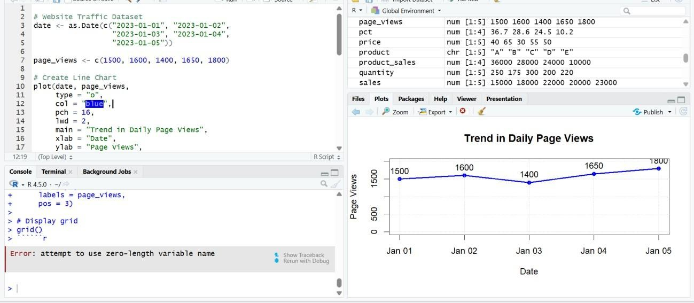
Observation: Page views rose from 1,500 to 1,600, dipped to 1,400 on 2023-01-03, then climbed to 1,650 and reached the peak of 1,800 on 2023-01-05. Overall the trend is upward.

PROGRAM 2: Bar Chart of Top N Days by Click-through Rate
Question: In R, generate a bar chart to show the top N days with the highest click-through rates. Label the chart elements.
# Dataset date <- c("2023-01-01", "2023-01-02", "2023-01-03", "2023-01-04", "2023-01-
05")
ctr <- c(2.3, 2.7, 2.0, 2.4, 2.6)

# Select the top N days (N = 3) N <- 3
ord <- order(ctr, decreasing = TRUE)[1:N] top_date <- date[ord] top_ctr <- ctr[ord]

# Bar Chart bp <- barplot(top_ctr,
names.arg = top_date, main = paste("Top", N, "Days by Click-through Rate"), xlab = "Date", ylab = "Click-through Rate (%)", col = "#F28E2B", ylim = c(0, 3.2))
text(bp, top_ctr, labels = paste0(top_ctr, "%"), pos = 3)

Output 2: Top Days by Click-through Rate Bar Chart

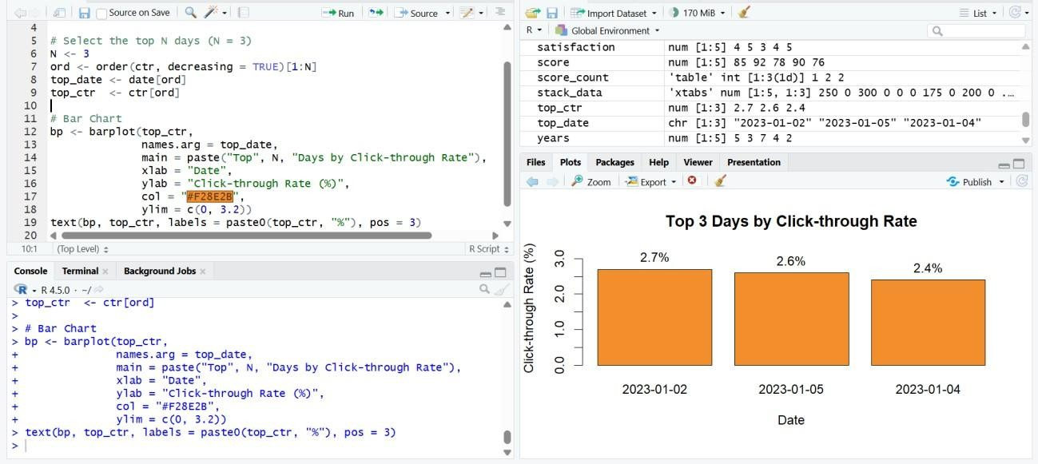
Observation: With N = 3, the top days are 2023-01-02 (2.7%), 2023-01-05 (2.6%) and 2023-01- 04 (2.4%). The days 2023-01-01 (2.3%) and 2023-01-03 (2.0%) are left out. The click-through rate was lowest on the day with the fewest page views.

PROGRAM 3: Stacked Area Chart of User Interactions
Question: In R, build a stacked area chart to display the distribution of user interactions (likes, shares, comments) on the website.
Note: this data is not given in the question, so sample values are assumed for the demonstration. Replace them with your actual data if you have it.

Date | Likes | Shares | Comments
2023-01-01 | 120 | 40 | 25
2023-01-02 | 150 | 55 | 30
2023-01-03 | 110 | 35 | 20
2023-01-04 | 170 | 60 | 35
2023-01-05 | 190 | 70 | 45

# Dataset (interaction counts are assumed sample data)
date <- as.Date(c("2023-01-01", "2023-01-02", "2023-01-03", "2023-01-04",
"2023-01-05"))
likes <- c(120, 150, 110, 170, 190) shares <- c(40, 55, 35, 60, 70) comments <- c(25, 30, 20, 35, 45)

# Cumulative totals for stacking top1 <- likes top2 <- likes + shares top3 <- likes + shares + comments # Stacked Area Chart plot(date, top3, type = "n", main = "Distribution of User Interactions", xlab = "Date", ylab = "Number of Interactions", ylim = c(0, max(top3) * 1.15), xaxt = "n")
polygon(c(date, rev(date)), c(top3, rev(top2)), col = "#59A14F", border =
"white")
polygon(c(date, rev(date)), c(top2, rev(top1)), col = "#F28E2B", border =
"white")
polygon(c(date, rev(date)), c(top1, rep(0, length(date))), col = "#4E79A7", border = "white")
axis.Date(1, at = date, format = "%Y-%m-%d")
legend("topleft", legend = c("Likes", "Shares", "Comments"), fill = c("#4E79A7", "#F28E2B", "#59A14F"), title = "Interaction")

Output 3: User Interactions Stacked Area Chart

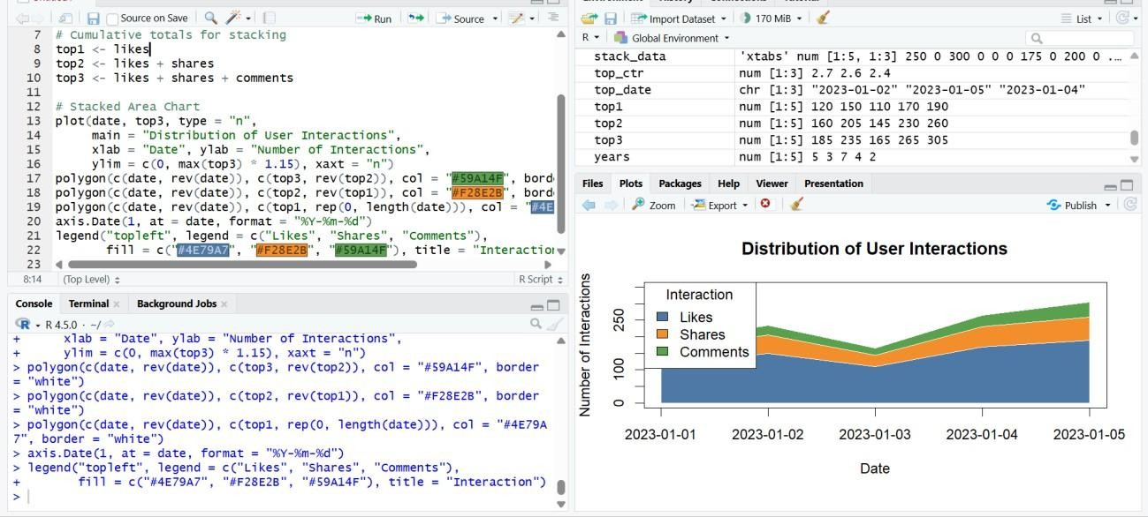
Observation: Likes form the largest layer on every day (about 64% of all interactions), followed by shares (about 23%) and comments (about 13%). Total interactions fell to the lowest value (165) on 2023-01-03 and peaked at 305 on 2023-01-05, following the same pattern as the page views.

PROGRAM 4: Tableau Dashboard: Traffic Source Map and Page Views by Source
Question: In Tableau, create a dashboard with an interactive map showing traffic sources and a bar chart displaying page views by source.
Note: traffic source data is not given in the question, so sample values are assumed (they add up to the same total of 7,950 page views as the daily data).
Traffic Source | Country | Page Views
Organic Search | India | 2800
Direct | USA | 1900
Social Media | UK | 1300
Referral | Germany | 1100
Email | Australia | 850

Tableau Steps
- Open Tableau and connect to the traffic source data (Excel/CSV) with the fields Traffic Source, Country and Page Views.
- Check that Country has the geographic role Country/Region (a globe icon appears next to it); set it manually if needed.
- Create a worksheet named “Traffic Source Map”. Double-click Country to create the map, drag Traffic Source to Color and Page Views to Size.
- Add the title “Traffic Sources by Country”, show the Traffic Source legend and add Page Views to Tooltip.
- Create a worksheet named “Page Views by Source”. Drag Traffic Source to Columns and Page Views to Rows; select Bar in the Marks card.
- Sort the bars in descending order, show mark labels and add the title “Page Views by Traffic Source”.
- Create a new Dashboard, set the size to Automatic, and drag in the map and the bar chart.
- Add the title “Website Traffic Source Dashboard”, click the “Use as Filter” icon on the map and add a Traffic Source quick filter (Show Filter).
- Test the dashboard by clicking a country on the map or a bar and checking that the other view updates.

Output 4: Traffic Source Dashboard (Tableau)

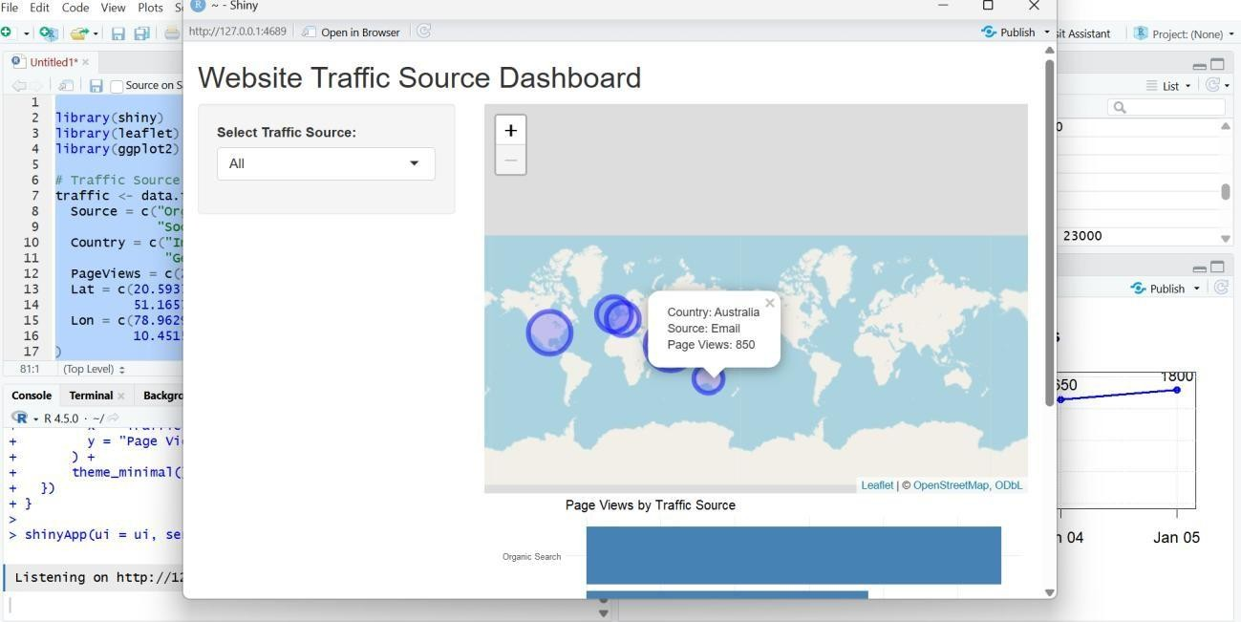
Observation: Organic Search brings the most page views (2,800, about 35% of the total) and Email the fewest (850, about 11%). Clicking a country on the map filters the bar chart to its traffic source, and the quick filter allows exploration by source.

Procedure
- Open Tableau and import the Website Traffic dataset; create the line chart of page views.
- In R, sort the click-through rates with order(), select the top N days and draw the bar chart using barplot().
- Create the likes, shares and comments data, calculate cumulative totals and draw the stacked area chart using polygon().
- Import the traffic source data into Tableau and create the map and the bar chart as separate worksheets.
- Combine the worksheets into a dashboard, add a title, and enable filters.
- Test the dashboard interactivity.

Result
The Website Traffic data was successfully visualized using a Tableau line chart of page views, a bar chart of the top days by click-through rate, a stacked area chart of user interactions, and an interactive Tableau dashboard with a traffic source map and a page views by source bar chart.

